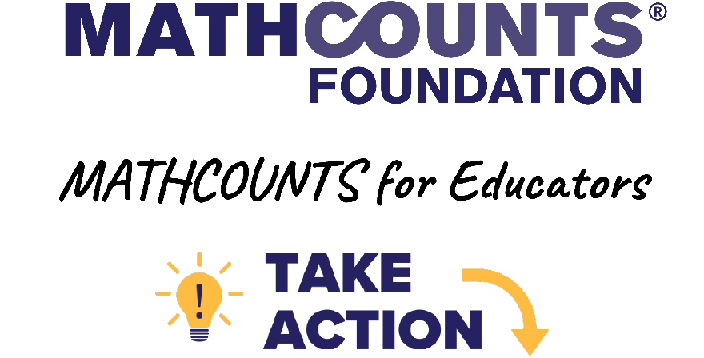

INCLUDED IN THIS SNACKS INFO PACKET:
- Template: Snack Request Letter to Stores – Feel free to put this request on your own school’s or group’s letterhead for local personalization!
- Potential Stores to Ask for Snacks or Gift Card Donations
- Template: Snack Request Email to Parents/Guardians
- Template: Snack Request Email to PTA – Feel free to modify this for other local community volunteer organizations that may help!
[Highlighted fields in brackets] should be updated by the coach or club leader. When 2 words are separated by a slash, choose the appropriate word for you. For example, for the field “[coach / club leader]” you would put either “coach” or “club leader” in your version.

The MATHCOUNTS Foundation cannot guarantee this will work for your school/group. The details in this packet are simply suggestions from volunteers and educators. By using this packet, you understand and agree MATHCOUNTS: (a) is not liable for actions your school or organization takes, (b) has not vetted the organizations or external links included in this packet, and (c) does not necessarily have any official partnerships or agreements with your school/group or with the organizations listed in this packet.
Good luck and thank you for leading students in a MATHCOUNTS program!

Template: Snack Request Letter to Stores

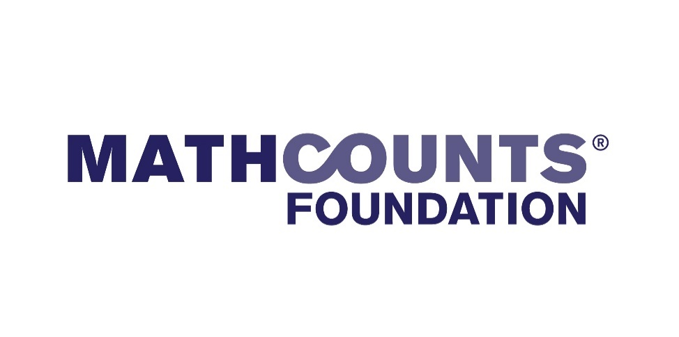

Hello,
My name is [first and last name], and I am inquiring about an in-kind donation on behalf of the MATHCOUNTS team I lead at [school or group name], which has [competition practices / club meetings] taking place throughout the school year.
MATHCOUNTS is a 501(c)(3) non-profit organization that provides engaging math programs to US middle school students of all ability levels to build confidence and improve attitudes about math and problem solving.
We would love to provide our incredible students with snacks during our [event / team practices / club meeting] while they engage in fun, influential math activities that will prepare them for their future.
As a thank you, I’m happy to recognize your organization during our meetings and let my students’ parents know about your donation!
If you would like to learn more about MATHCOUNTS, please visit their website at mathcounts.org. To learn more about how our [school / group] participates in this program, you can contact me at [email].
We are committed to expanding access to math for all students and making it FUN in the process!
Thank you for your time and consideration!
Sincerely,
[First and last name]
MATHCOUNTS [club leader / coach]
[School or group name]
[Title or position at school or group]
[Add EIN (Tax ID) if your school or group is a 501(c)(3) or NCES School ID]
Potential Stores to Ask for Snacks or Gift Card Donations
Note: MATHCOUNTS does not have any relationships with or reasons to suggest these companies other than knowing volunteers have had some success receiving donations from them at the local level in the past.
TARGET
- Fill out their request form with your school/group info ( get PDF here or search “Target Community Giving Form”), print it and the letter above, and drop it off at Customer Service.
- Locations have individual donation budgets, so feel free to ask multiple stores.
- Max donation amount of $500 per year, per agency, and most donations are $50-$100.
COSTCO
- Fill out their request form with your school/group info (get PDF here or search “Costco Warehouse Donation Request Form”), print it and the letter above, and drop it off at Customer Service.
- Locations have individual donation budgets, so feel free to ask multiple stores.
- Ask for a donation between $50-$150 for best results
OTHER GROCERY STORES
Search for the name of the grocery chain near you and “donation request” or “community giving” to see what your store makes available. Grocery stores each have their own way of handling donation requests. You may need to provide your school or group EIN (Tax ID) or NCES School ID.
- Giant Food: https://giantfood.com/pages/donations
- Harris Teeter: https://donations.harristeeter.com/request-a-donation
- H-E-B: From the H-E-B website FAQ: “How do I request charitable funding from H-E-B, Central Market or Mi Tienda? If your organization is requesting a charitable donation of $200 or less, you can visit your local H-E-B, Central Market or Mi Tienda, and a store Partner can provide you with an application to submit in-person.”
- Kroger: https://www.thekrogerco.com/community/
- Meijer: https://meijercommunity.com/support
- Publix: https://corporate.publix.com/community/requests
- Walmart: https://walmart.org/how-we-give/program-guidelines/spark-good-local-grants-guidelines
- Local grocers: Email local grocery stores or drop off a printed request letter to ask for snack donations or a gift card.
COFFEE SHOPS & RESTAURANTS
Visit your local chain (avoid busy times) and ask the owner or location manager directly. Many fast-food and coffee chains (Dunkin Donuts, McDonald’s, Wendy’s, Burger King and more) will donate to local schools and teams, but those donation decisions are made by franchise owners.

- Panera: Panera has multiple opportunities to fundraise: https://www.panerabread.com/en-us/food-values/community.html
- Local coffee shops: Email local cafes and coffee shops or drop off a printed request letter to ask for snack donations or a gift card.
Template: Snack Request Email to Parents/Guardians

Subject: Please support your student’s MATHCOUNTS [club / team]!
Hello,
My name is [name], and I am the [teacher / volunteer / coach] in charge of your student’s MATHCOUNTS [club / team] at [school or group name].
To keep students engaged in the program and excited to spend time with friends outside of the classroom, I am asking if you could participate in our snack schedule.
[Add schedule info – amount to bring, timing (frequency or date), type of snack(s) to bring]
If you would like to learn more about MATHCOUNTS, visit their website at mathcounts.org. To learn more about how our [school / group] participates in this program, you can contact me at [email].
MATHCOUNTS is committed to expanding access to math for all students and making it FUN in the process. We are so happy your child is participating in MATHCOUNTS this year!
Thank you for your help!
[Name]
MATHCOUNTS [club leader / coach]
[School or group name]
[Title or position at school or group]

Template: Snack Request Email to PTA

Subject: Please support our school’s participation in MATHCOUNTS!
Hello,
My name is [name], and I am the [teacher / volunteer / coach] in charge of the MATHCOUNTS program at [school name].
To keep students engaged in the program and excited to spend time with friends outside of the classroom, I am asking if you would allocate PTA funding for snacks.
[Add snack request info: amount requested, timing (frequency or date), etc.]
If you would like to learn more about MATHCOUNTS, visit their website at mathcounts.org. To learn more about how our school participates in this program, you can contact me at [email].
MATHCOUNTS is committed to expanding access to math for all students and making it FUN in the process. I am thrilled to lead [School name]’s participation in MATHCOUNTS this year and hope you’ll join me in supporting these fantastic students!
Thank you for your time and consideration!
Sincerely,
[Name]
MATHCOUNTS [club leader / coach]
[School name]
[Title or position at school]

