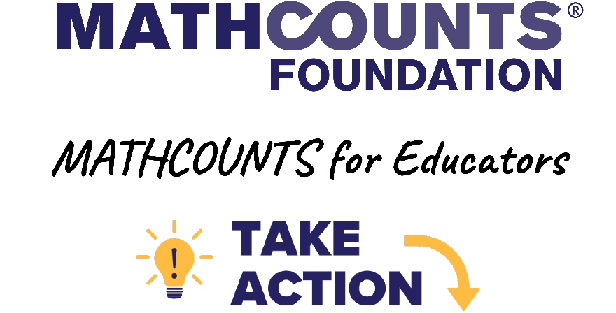

INCLUDED IN THIS EMAIL TEMPLATES PACKET:
- Template: Email to Parents/Guardians about the MATHCOUNTS Competition Series
- Template: Email to Parents/Guardians about the National Math Club
- Template: Email to Parents/Guardians about Both MATHCOUNTS Programs
[Highlighted fields in brackets] should be updated by the coach or club leader. When 2 words are separated by a slash, choose the appropriate word for you. For example, for the field “[coach / club leader]” you would put either “coach” or “club leader” in your version.

Please feel free to tailor these email templates to suit your needs! Good luck and thank you for leading students in a MATHCOUNTS program!

Email to Parents/Guardians about the MATHCOUNTS Competition Series
Subject Line: Opportunity for Your Child: MATHCOUNTS Competition Series
Greetings, Parents & Guardians!
With a new school year comes a new year of the MATHCOUNTS Competition Series, and I would like to invite your child to join our team this year. Participating in MATHCOUNTS is a great math enrichment opportunity for students to challenge themselves and improve their problem-solving skills. I would be thrilled to coach your child this year! [Insert co-coach info, if applicable.]
If you’re unfamiliar with the Competition Series, there are 3 main components for all schools:
- An in-person Chapter Competition, which takes place in February. Our school can send [number of registered competitors for school, 1-14] students to represent us at this event. I’ll share more event info as soon as I have it from our local MATHCOUNTS coordinator.
- A School Competition, which takes place in [November / December / January / between November and January]. The coach can either use this for practice or host an official event to select the students to advance to the Chapter Competition. [Insert info about how you’ll be determining chapter competitors, if known.]
- Teams practices that are led by a coach to prepare students for competitions. [Insert group-specific info, if desired: requirements, when/where/how frequent meetings will be.]
Depending on how they do at the chapter level, the students can advance to the in-person State Competition in March. Then, the top 4 students from each state receive an all-expenses-paid trip to compete at the National Competition, which takes place in May.
MATHCOUNTS problems are unique, unlike anything your child will see in their regular math classes. They focus on critical thinking and problem-solving skills and are aligned with many sets of standards across the country. (Sample problems are in the School Handbook preview on their website. Coaches have access to all 250 handbook problems, which I’ll use with students to prepare for competitions this year!)
I hope your child is able to join us for the Competition Series this year! MATHCOUNTS is a fun, exciting, challenging experience that helps kids think of math in a different way, and they’ll build skills that will serve them well in their current math class and beyond.
Please feel free to respond with any questions or look through the MATHCOUNTS list of FAQs. If you can’t find what you’re looking for or have a question I can’t answer, you can also reach out to MATHCOUNTS directly at info@mathcounts.org.
Looking forward to working with you this year,
[Name]
MATHCOUNTS Coach
[Title or Position at School]

Email to Parents/Guardians about the National Math Club
Subject Line: Opportunity for Your Child: Math Club
Greetings, Parents & Guardians!
I would like to invite your child to join our MATHCOUNTS club this year. Participating in the National Math Club is a great math enrichment opportunity for students to challenge themselves and improve their problem-solving skills. I would be thrilled to work with your child this year! [Insert co-club leader info, if applicable.]
If you’re unfamiliar with this MATHCOUNTS program, the National Math Club involves informal meetings run by a club leader all year long. Students play math games and work together on explorations, fun STEAM projects and themed problem sets.
We can also go for additional recognition and receive awards and entry into prize drawings. You can look here at other clubs that have been recognized online by MATHCOUNTS.
MATHCOUNTS activities are unique, unlike anything your child will see in their regular math classes. They focus on critical thinking and problem-solving skills and are aligned with many sets of standards across the country.
I hope your child will join us in MATHCOUNTS this year! It’s a fun, exciting, challenging experience that helps kids think of math in a different way, and they’ll build skills that will serve them well in their current math class and beyond.
Please feel free to respond with any questions or look through the MATHCOUNTS list of FAQs. If you can’t find what you’re looking for or have a question I can’t answer, you can also reach out to MATHCOUNTS directly at info@mathcounts.org.
Looking forward to working with you this year,
[Name]
MATHCOUNTS Club Leader
[Title or Position at School or Group]

Email to Parents/Guardians about Both MATHCOUNTS Programs
Subject Line: Opportunity for Your Child: MATHCOUNTS
Greetings, Parents & Guardians!
I would like to invite your child to join our MATHCOUNTS club this year. It’s a great math enrichment opportunity for students to improve their problem-solving skills, and I would be thrilled to work with your child this year! [Insert co-coach or co-club leader info, if applicable.]
If you’re unfamiliar with MATHCOUNTS, it includes 2 programs, the Competition Series and National Math Club. Your child can participate in either or both through our school! There are 3 main components of the Competition Series that are for all participating schools:
- An in-person Chapter Competition, which takes place in February. Our school can send [number of registered competitors for school, 1-14] students to represent our school at this event. I’ll share more event info as soon as I have it from our local MATHCOUNTS coordinator.
- A School Competition, which takes place in [November / December / January / between November and January]. The coach can either use this for practice or host an official event to select the students to advance to the Chapter Competition. [Insert info about how you’ll be determining chapter competitors, if known.]
- Teams practices that are led by a coach to prepare students for competitions. [Insert group-specific info, if desired: requirements, when/where/how frequent meetings will be.]
Depending on how they do at the chapter level, the students can advance to the in-person State Competition in March. Then, the top 4 students from each state receive an all-expenses-paid trip to compete at the National Competition, which takes place in May.
The National Math Club involves informal meetings run by a club leader all year long. Students play math games and work together on explorations, fun STEAM projects and themed problem sets.
We can also go for additional recognition and receive awards and entry into prize drawings. You can look here at other clubs that have been recognized online by MATHCOUNTS.
MATHCOUNTS activities and problems are unique, unlike anything your child will see in their regular math classes. They focus on critical thinking and problem-solving skills and are aligned with many sets of standards across the country.
I hope your child will join us in MATHCOUNTS this year! It’s a fun, exciting, challenging experience that helps kids think of math in a different way, and they’ll build skills that will serve them well in their current math class and beyond.
Please feel free to respond with any questions or look through the MATHCOUNTS Competition and Club FAQs. If you can’t find what you’re looking for or have a question I can’t answer, you can also reach out to MATHCOUNTS directly at info@mathcounts.org.
Looking forward to working with you this year,
[Name]
MATHCOUNTS Coach
[Title or Position at School]

